| **Project Title:** BetSyncDB  **Collaborators:** Tina Nosrati; Genaro Sanchez Feliz; Emily Morra; Cheryl Skrzat    **Description:** BetSyncDB is a database system for a sports betting platform. Our mission is to create a well-structured and efficient system that can handle different parts of a betting app, such as player accounts, matches, bets, odds, and results. The system will make it easy to store, update, and retrieve information so players can place bets and track outcomes in real-time. It's designed to be flexible, secure, and scalable for future growth.  **Table of Contents**  Business Rules and Relationships 2  Entities and Attributes 3  ER Diagram 4 |
| --- |

# **Business Rules and Relationships**

* Each **PLAYER** may place zero or many **BET**s (1:0..*)
* Each **BET** is placed by one and only one **PLAYER** (1:1)
* Each **BET** is placed on one and only one **MATCH** (1:1)
* Each **MATCH** may have zero or many **BET**s (1:0..*)
* Each **MATCH** has one or many **ODDS** (1:M)
* Each **ODDS** belongs to one and only one **MATCH** (1:1)
* Each **PLAYER** may have zero or many **TRANSACTIONS** (1:0..*)
* Each **TRANSACTION** belongs to one and only one **PLAYER** (1:1)
* Each **TEAM** can play in one and only one **SPORT** (1:1)
* Each **SPORT** may have zero or many **TEAM**s (1: 0..*)
* Each **TEAM** may play in one and only one **SPORT** (1:1)
* Each **TEAM** can participate in zero or many **TEAM_MATCH** (1:0..*)
* Each **TEAM_MATCH** belongs to one and only one **TEAM** (1:1)
* Each **MATCH** may contain one or many **TEAM_MATCH** (1:M)
* Each **TEAM_MATCH** belongs to one and only one **MATCH** (1:1)
* Each **ADMIN** may set zero or many **MATCH**es (1:0..*)
* Each **MATCH** is set by one and only one **ADMIN** (1:1)
* Each **ADMIN** may set zero or many **ODDS** (1:0..*)
* Each **ODDS** are set by one and only one **ADMIN** (1:1)

# 

# 

# 

# 

# 

# 

# 

# 

# **Entities and Attributes**

| **Entity Name** | **Keys** | **Entity Attributes** |
| --- | --- | --- |
| PLAYER | player_id (PK) | username  Fname  Lname  email  password_hash  balance  date_joined |
| MATCH | match_id (PK)  team_1 (FK)  team_2 (FK)  admin_id (FK) | match_date  status (upcoming, live, finished)  final_score  match_location |
| TEAM | team_id (PK)  sport_type (FK) | team_name |
| SPORT | sport_type (PK) | football  basketball  baseball  hockey |
| TEAM_MATCH | team_match_id (PK)  match_id (FK)  team_id (FK) |  |
| BET | bet_id (PK)  player_id (FK)  match_id (FK)  odds_id (FK) | bet_type (e.g., win/loss)  bet_amount  Potential_payout (calculated)  bet_status (pending, won, lost, canceled)  time_placed |
| ODDS | odds_id (PK)  match_id (FK)  admin_id (FK) | Team_1_odds (percentage)  team_2_odds  draw_odds  date |
| TRANSACTION | transaction_id (PK)  player_id (FK) | amount  type (deposit, withdrawal, bet)  date  time  status |
| ADMIN | admin_id (PK) | username  Password_hash |

# **ER Diagram**

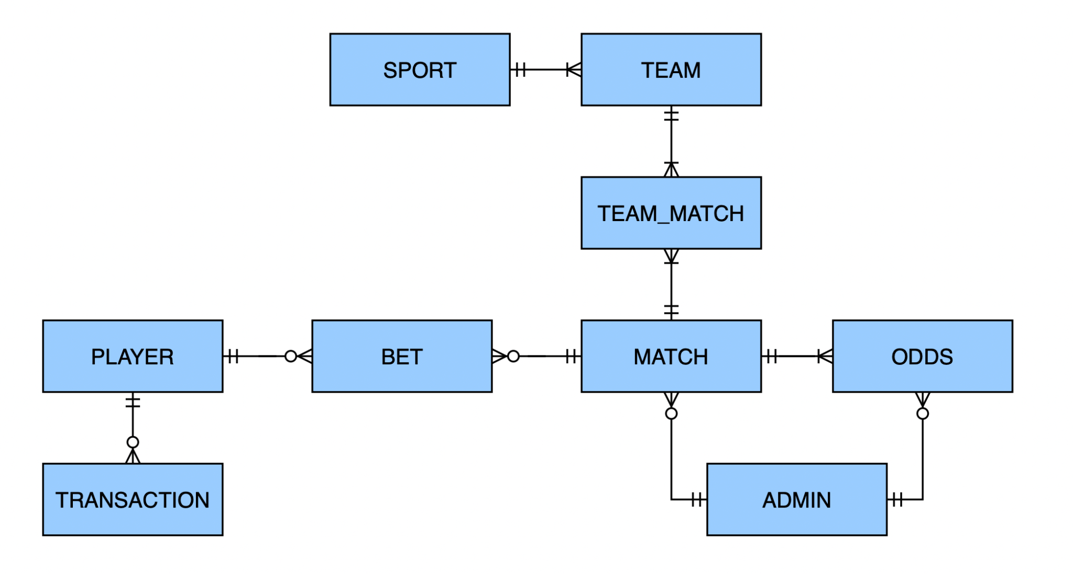

Normalization:

Functions: (3-4)

* Place a bet
* Complete a transaction
* Confirm bet
  + Confirm odds?
* Confirm transaction

Procedures: (3-4)

* Add new player

Triggers: (3-4)

* Age (21+)
* User already exists
* No money in account to place bet
* No money to withdraw
* Login credentials are not in system.
* Check match exists before creating new bet
* Change player balance after bet has been created

User Interface:

Queries:

exception handling:

Documentation:

* List of Business Rules
* Entity-Relationship (ER) Diagram
* Normalization Tables
* Data Dictionary (Meta Data)
* Task Distribution Table

Presentation

Project Report